GOAL: detect people's faces in crowds.

APPROACH: first of all, Haar Cascades were tried, but because of the poor face detection in the sample image, other options were considered. Then, state of the art YOLOv3 method was chosen. Compared to other methods it offered comparable accuracy with faster detection.
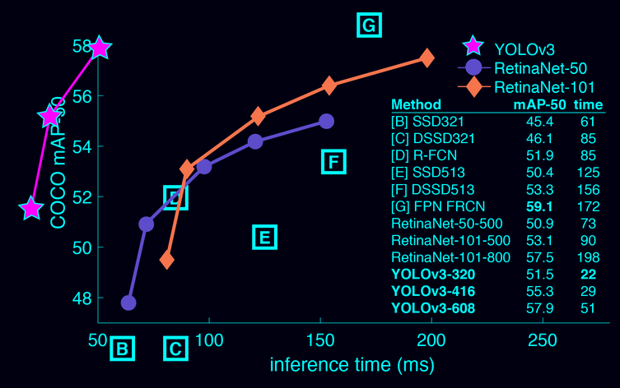

More precisely, Alexey’s fork of Pjreddie darknet was used. After running it, it became obvious that it would take longer than a month to train on the current laptop’s CPU. This lead to trying to run it on Google Cloud and Floydhub, but because of compatibility and other issues the decision was made to build a personal computer with a descent GPU card in order to achieve results faster.

Chosen components were: GeForce 1060 6Gb, RAM 16Gb DDR3 1333Mhz, second generation i5 CPU and HDD. After a successful test, GPU showed 95-99% utilization, which proved that other system parameters did not cause a performance bottleneck.

All trainings were performed using weights pretrained on Imagenet and learning rate decreasing after every few thousands of iterations.

First trainings were ran by using hundreds of images containing mostly 1 or 2 faces with relatively large size (Illustration 1). The result was good in similar images (Illustration 2 and 3), but not in the desired ones (crowds of people, Illustration 4). This showed a mismatch between sample distributions.

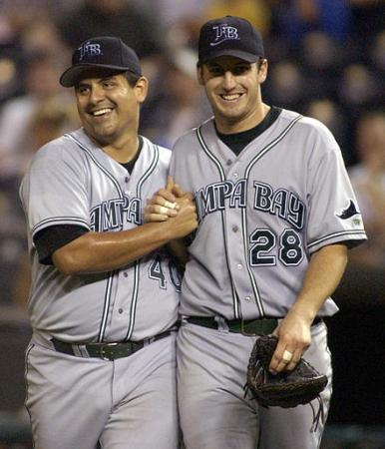
Illustration 1. 386*450 pixels

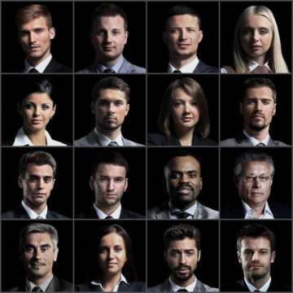
Illustration 2: 360*360 pixels
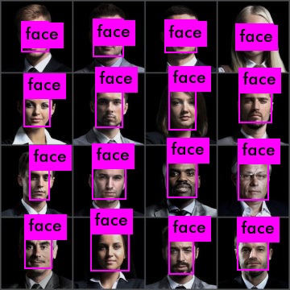
Illustration 3: 360*360 pixels

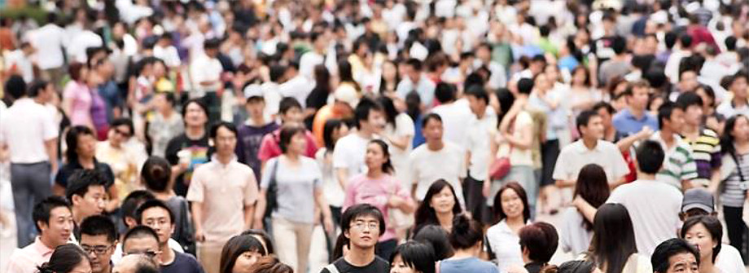
Illustration 4. 920*335 pixels
Next step was to reduce the number of previous images used for detection and add around 20 images of crowds with, on average, 30 faces per image. This improved detection in the Illustration 4, while not loosing accuracy in Illustration 3, but looking for better results it was decided to train only on the images of crowds.

RESULT: Weights were saved every 100 iterations and final weights “face_1300.weights” were chosen as they showed best accuracy. These final weights were trained only on crowd images. They showed even a better detection on a test image (Illustration 5) similar to training images, but not in the image of higher resolution, where the size of faces is relatively smaller (Illustration 6). To repeat results, the following line should be run in the terminal: ./darknet detector test obj.data cfg/face.cfg backup/face_1300.weights

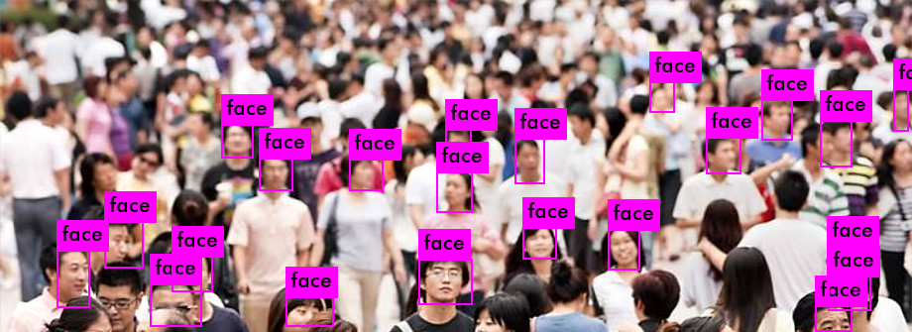
Illustration 5: 920*335 pixels
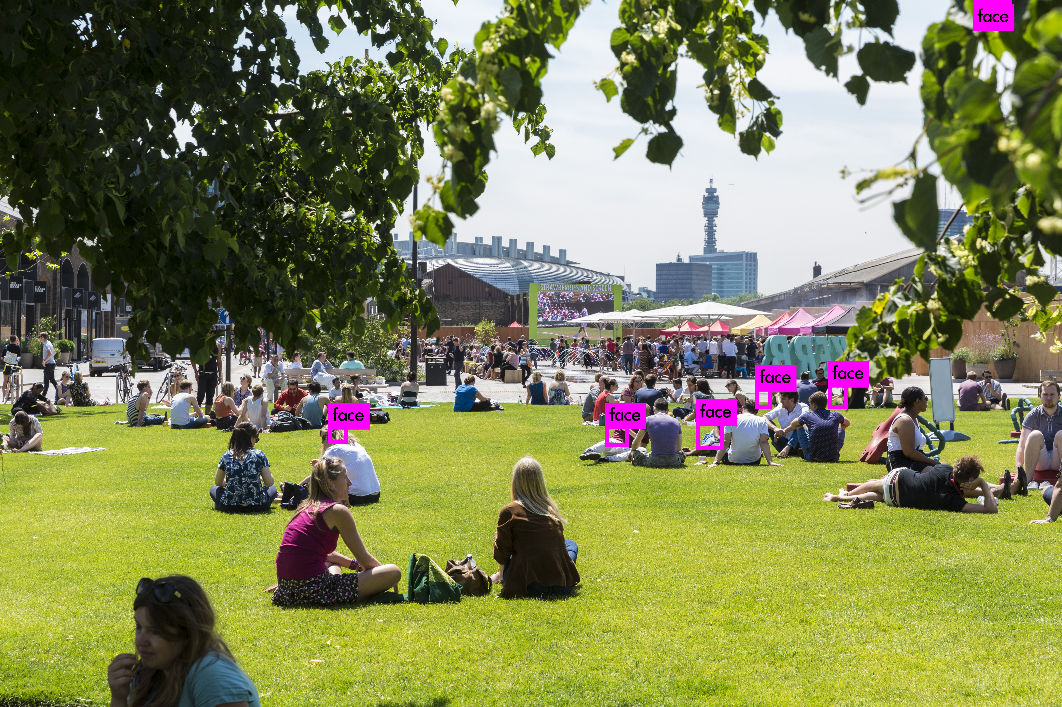
Illustration 6: 5000*3333 pixels

FUTURE STEPS: There are a number of ways to improve the accuracy. First of all, one of the biggest impacts should be given by recalculating anchors (not done before training for this task because of the current issues with OpenCV) as faces are usually smaller than the items previously detected using YOLOv3. Also bigger resolution images should be used for the training. Accuracy would increase by increasing dimensions (height and width in file /cfg/face.cfg) into which image is transformed while being trained or tested as less features are lost during compression. It is expected that changing ratio between height and width (/cfg/face,cfg) would help as well, because it was trained on the ratio giving a square image, whereas used images (containing images of crowds) had width bigger than height. Finally, more images should be used for training and more different training parameters should be tried.

